Section A: Multiple Choice (Nos. 1-4, 1-mark each)

Use the multiple choice answer sheet in the ANSWER BOOKLET

1. A suitable catalyst for the synthesis of ammonia is:

(A) platinum
(B) iron
(C) concentrated H₂SO₄
(D) nitric acid

2. A dry precipitate of Mg(NH₄)PO₄.6H₂O was obtained and weighed . It was found
to weigh 6.47 g. How much of this precipitate is phosphorus?

(A) 0.82 g
(B) 1.46 g
(C) 0.03 g
(D) 1.64 g

3. Damage to the Earth's stratospheric ozone has mainly been due to a certain group
of compounds. Which of the compounds given below is an example of this group
of compounds?

(A) CClF₃
(B) CCl₂FH
(C) CF₂I₂
(D) CF₃H

4. Which of the following IUPAC names is correct for the compound given below?

Cl H H H F
| | | | |
H − C − C − C − C − C = C
| | | | | |
F H Cl H H F

(A) 1,1,6-trifluoro-4,6-dichlorohexane
(B) 4,6-dichloro-1,1,6-trifluoro-2-hexene
(C) 1,1,6-trifluoro-4,6-dichlorohexene
(D) 4,6-dichloro-1,1,6-trifluoro-1-hexene

Answer Booklet for Sections A and B Student No....................................
INSTRUCTIONS
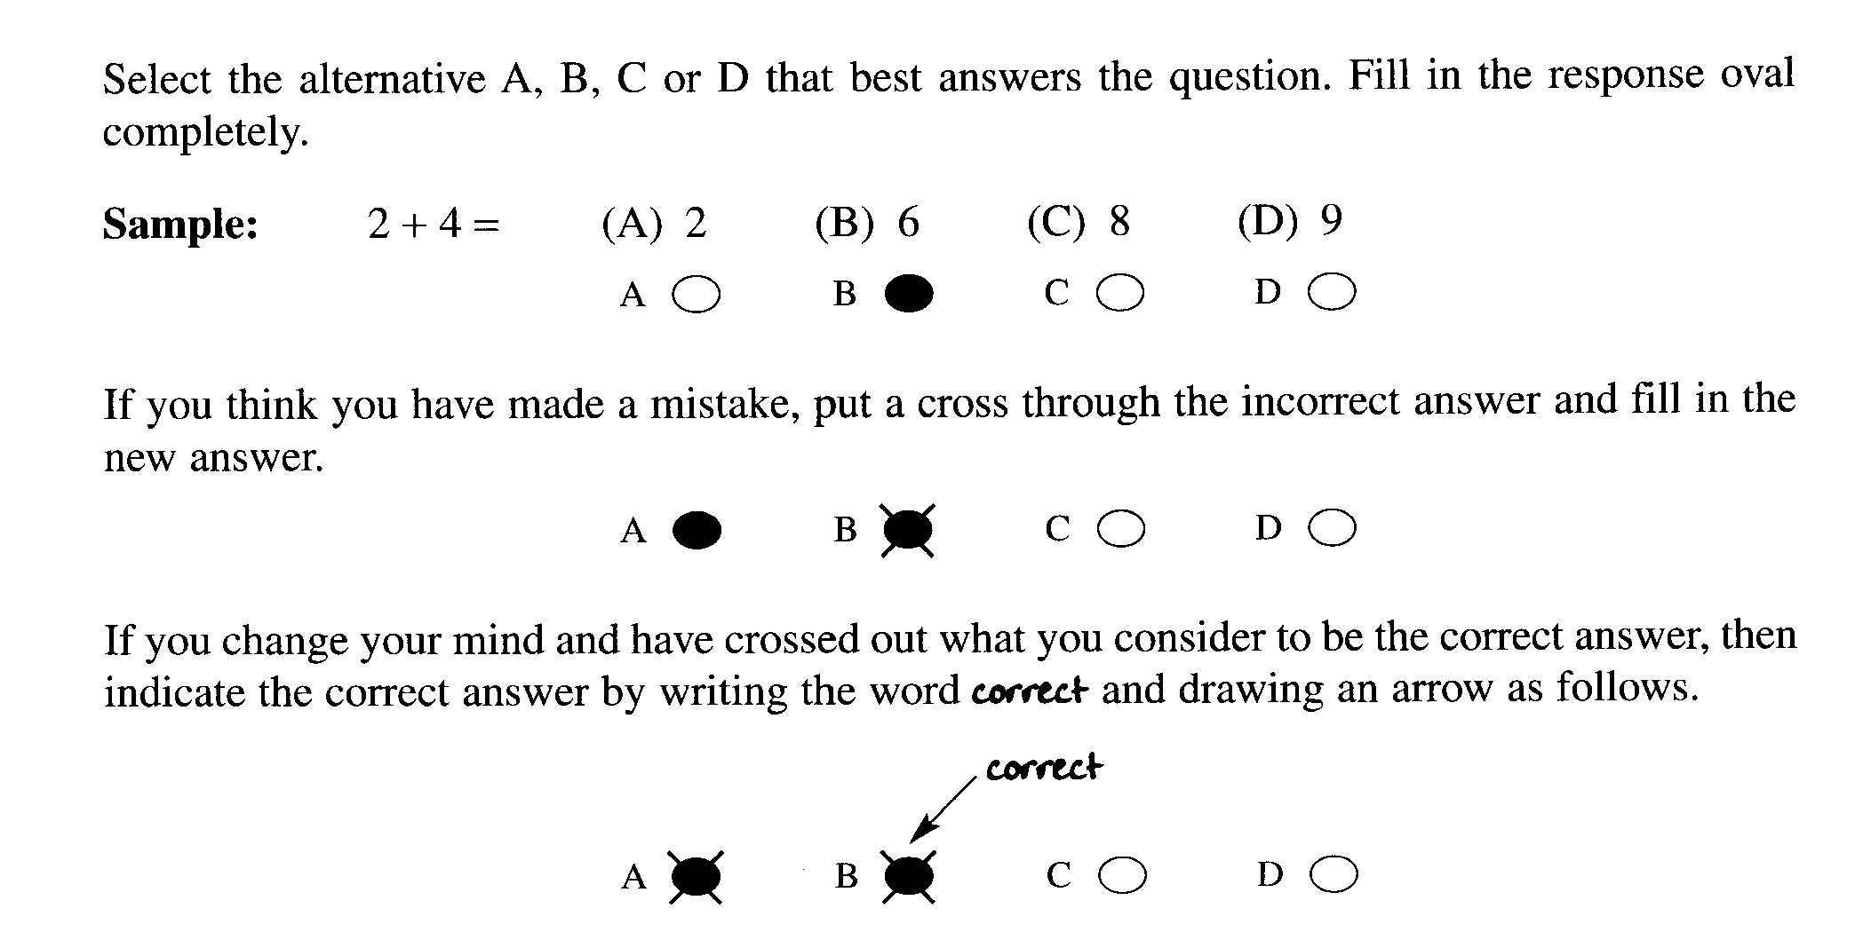

Section A

Multiple Choice Answer Sheet

1. A O B O C O D O

2. A O B O C O D O

3. A O B O C O D O

4. A O B O C O D O
Section B. Answer the questions in the spaces provided. Show all relevant
working in questions involving calculations MARKS

5. Describe a chemical test and the result to identify

(a) copper ions ........................................................................................................ 1

.............................................................................................................................

(b) lead ions ........................................................................................................... 1

.............................................................................................................................

(c) calcium ions ....................................................................................................... .1

............................................................................................................................

6. A student investigated the sulfate content of a fertiliser. Firstly, he dissolved
3.2 g of fertiliser in distilled water. Then, he added barium chloride
solution until no further precipitate formed. He, then filtered, washed, dried
and weighed the precipitate.

(a) Write a net ionic equation for the formation of the precipitate. 1

..........................................................................................................................

(b) If the student recovered 5.6 g of barium sulfate. What percentage of this
fertiliser is sulfate ions? 2

.........................................................................................................................

.........................................................................................................................

.........................................................................................................................

...........................................................................................................................

(c) If the student assumed the original fertiliser consists of ammonium
sulfate only, what is the percentage of nitrogen in the fertiliser? 2

............................................................................................................................

............................................................................................................................

.............................................................................................................................
Student No. ....................................

MARKS

7. (a) List three different chemical occupations 1

........................................................................................................................

........................................................................................................................

........................................................................................................................

(b) (i) Choose one of these occupations and outline the role of the chemist. 1

.....................................................................................................................

.......................................................................................................................

........................................................................................................................

(ii) Explain a chemical principle used by this chemist. 1

..........................................................................................................................

..........................................................................................................................

..........................................................................................................................

...........................................................................................................................

...........................................................................................................................

8.. Identify the origins of minerals in oceans. 2

............................................................................................................................

.............................................................................................................................

..............................................................................................................................

...............................................................................................................................

MARKS
9. (a) Use equations to show the destruction of ozone in the stratosphere by
a CFC. 3

.......................................................................................................................

.......................................................................................................................

.......................................................................................................................

.......................................................................................................................

(b) Explain the importance of the ozone layer to life on Earth. 1

..........................................................................................................................

..........................................................................................................................

..........................................................................................................................

..........................................................................................................................

10. Describe two methods which you would use, including details of the
preparation which you would do to determine the dissolved solids
content of a sample of river water. 3

.............................................................................................................................

..............................................................................................................................

...............................................................................................................................
.
................................................................................................................................
.
................................................................................................................................

.................................................................................................................................

.................................................................................................................................

.................................................................................................................................

.................................................................................................................................

Student No. ..............................

MARKS

11. (a) Draw the Lewis electron dot structures for the oxygen molecule and the
oxygen free radical. 1

oxygen molecule oxygen free radical

(b) On the basis of molecular structure and bonding, explain the difference in:

(i) chemical reactivity of ozone and oxygen (O₂) 1

..............................................................................................................................

...............................................................................................................................

................................................................................................................................

................................................................................................................................

(ii) one physical property of ozone and oxygen (O₂) 1

...............................................................................................................................

................................................................................................................................

................................................................................................................................

.................................................................................................................................

.................................................................................................................................

 END OF TEST

